Prefix to Postfix Conversion
Problem Statement: You are given a valid prefix expression consisting of binary operators and single-character operands. Your task is to convert it into a valid postfix expression.
Prefix (Polish) notation places the operator before operands.
Postfix (Reverse Polish) notation places the operator after operands.
Examples
Example 1:
Input: expression = "+ab
Output: ab+

Example 2:
Input: expression = "*+ab-cd
Output: ab+cd-*
Algorithm
- Traverse the prefix expression from right to left.
- Use a stack to store operands.
- For each operator, pop two operands from the stack, combine them with the operator, and push the result back.
- The final item in the stack will be the postfix expression.

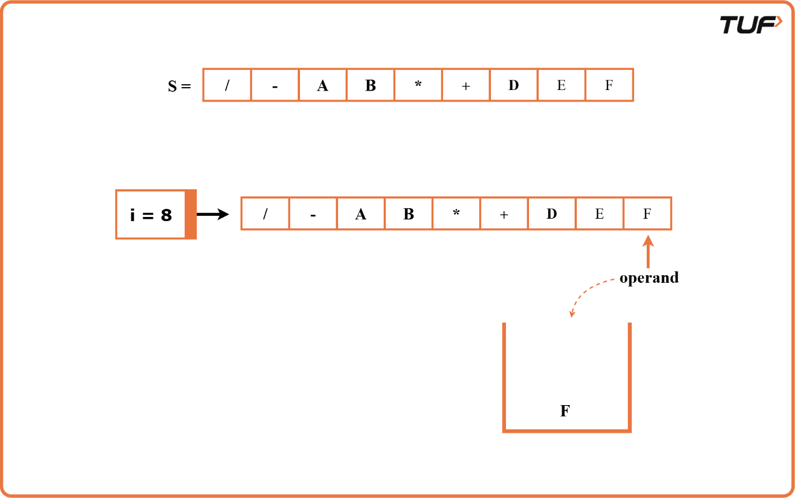
import java.util.*;

class PrefixToPostfix {
// Function to convert prefix to postfix
public String prefixToPostfix(String prefix) {
Stack<String> s = new Stack<>();
int n = prefix.length();

// Traverse the prefix expression from right to left
for (int i = n - 1; i >= 0; i--) {
char c = prefix.charAt(i);

// If the character is an operand, push it to the stack
if (Character.isLetterOrDigit(c)) {
s.push(String.valueOf(c));
} else {
// Pop two operands from the stack
String op1 = s.pop();
String op2 = s.pop();

// Form the new postfix expression and push back to stack
s.push(op1 + op2 + c);
}
}

// The final element in the stack is the result
return s.peek();
}
}

